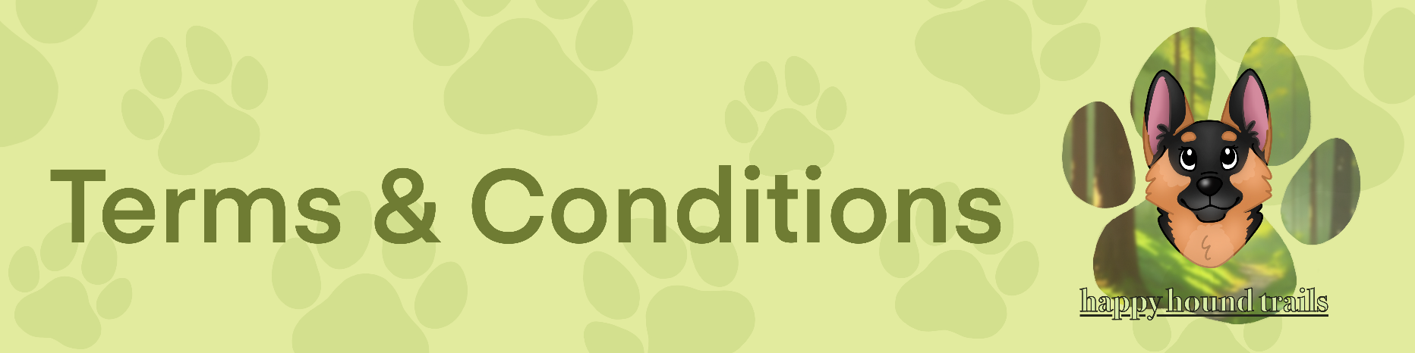Dog Walking Agreement

**Client authorization & terms 2024**

1. I agree to provide keys / arrange for keys or someone to be available for **Happy Hound Trails** dog walking /pet sitting /pet taxi/training arrangements.

2. I authorize **Happy Hound Trails** to obtain any emergency veterinary care that may be necessary during the time spent with my pet. Every effort will be made to contact the owner prior to obtaining emergency care. I accept responsibility for any charges related to this emergency care outside of **Happy Hound Trails’** insurance. I also authorize **Happy Hound Trails** to use an alternative veterinarian in the event my regular veterinarian is unavailable.

3. I agree to compensate **Happy Hound Trails** for any additional fees for providing emergency care outside of **Happy Hound Trails’** insurance, as well as any expenses incurred for unexpected visits, transportation, housing, food, or supplies.

4. I understand I will be responsible for any medical expenses and damages resulting from an injury to the pet sitter or other persons by the pet. I agree to cover and hold harmless **Happy Hound Trails** in the event of a claim by any person injured by the pet. I accept full liability for any loss or damage caused by my dog whilst being walked.

5. I agree to notify **Happy Hound Trails** of any concerns/complaints within 24 hours of any appointments.

6. I understand I must state if my pet shows aggression in any way. I understand I must fully disclose any quality or characteristic problems that might make my dog unsuitable for walks. **Happy Hound Trails** will not care for pets that imperil their safety or others.

7. I hereby grant permission for my dog to participate in group dog walks. I acknowledge and understand that group walks involve simultaneous exercise and social interaction of multiple dogs under the supervision of **Happy Hound Trails**. I further affirm that my dog is sociable, well-behaved, and able to interact positively with other dogs. I agree to inform the dog walker of any known behavioural issues or health concerns that may affect their dog's ability to safely participate in group walks.

Additionally, I acknowledge that while **Happy Hound Trails** will exercise due diligence in maintaining a safe environment, unforeseen circumstances and inherent risks associated with group activities may arise. I release the **Happy Hound Trails** from any liability related to interactions between my dog and other dogs during group walks and consents to my dog's participation with a full understanding of the potential risks involved.

**Happy Hound Trails Responsibilities**

8. **Happy Hound Trails** agrees to provide the services stated in this agreement in a reliable, kind, and trustworthy manner. In consideration of these services and as an express condition thereof, the client specifically waives and relinquishes any claims against **Happy Hound Trails**, except those occurring from the negligence of the dog walker.

9. **Happy Hound Trails** accepts no responsibility for the security of the premises or loss if other individuals have access to the home during the term of this agreement. During all assignments, dog walking will only be carried out bythe **Happy Hound Trails** owner, unless prearranged with the client. **Happy Hound Trails** accepts no responsibility for damages to the property if other people have access to the property.

10. **Happy Hound Trails** will not let any dog off his/her lead unless the owner has signed the off lead section below. If you do not wish for your dog to be off lead, please leave this part blank.

I consent to my dog being off lead during walks:

|  |  |
| --- | --- |
| Client name: Click or tap here to enter text. | Date: Click or tap to enter a date. |
| Client signature: Click or tap here to enter text. | |

11. If unforeseen circumstances occur when **Happy Hound Trails** cannot attend to your dog's needs due to illness etc, you will be notified straight away.

12. **Happy Hound Trails** is not responsible for damage sustained by a pet escaping because of a faulty lead/collar or a collar that is not properly fitted.

13. **Happy Hound Trails** will not be liable for the injury, disappearance, death, or fines of any pet with unsupervised access to the outdoors at the owner's property.

14. It is clearly understood that **Happy Hound Trails** shall not be held responsible for any damage to the client's property, or that of others, caused by the client's pets during the period in which they are in its care. The client has advised **Happy Hound Trails** of all situations, which will relieve it of liability for damage.

15. This agreement is valid for all future walks until a new agreement is signed. **Happy Hound Trails** reserves the right to terminate this agreement at any time if the agreement is not followed. Otherwise, 3 weeks notice will be given. The client may terminate this agreement at any time with one month's notice.

16. **Happy Hound Trails** agrees to love and care for your pet whilst you are away or at work.

**Cancellation Policy**

**Permanent slots**

Permanent days are booked each week continuously. You will be paying for the permanent slot whether it is used or not. Any cancellations will be at your discretion and will still be chargeable. Less than 1 weeks’ notice will be charged at half rate. A maximum of 14 working days can be cancelled for a holiday, anything over 14 days will be charged at a half rate to keep your slot. I do not offer term time only permanent slots.

**Payment**

Invoices will be sent out on the last day of the month and are due to be paid by the date stated on the invoice (15 days from when the invoice was sent). This can be done by bank transfer only. A reminder that the balance is due will be sent out 1 day before it is due. If payment is late, a late charge of £5 per day should be added to your invoice.

**Leads**

If your dog pulls excessively, please provide a lead to cater to this. Appropriate leads owned by the dog walker will be used. If you do not wish this to happen, please inform the dog walker.

**Service prices**

|  |  |  |
| --- | --- | --- |
| **Services** | **Price** | **Additional dog** |
| **1-hour walk** | £20 | £20 |
| **1-night boarding** | £50 | £45 |
| **1 hour training session** | £40 | £40 |
| **Daycare** | £50 | £45 |

**Weather**

**Heat**

When the weather is extremely hot and it's evident the dogs are struggling in the heat; 1 hour walks will be shortened accordingly. The visit will still be 1 hour in duration, but walks may be shortened to enable **Happy Hound Trails** to cool the dogs down and make sure they are comfortable before leaving. All dogs will have access to fresh water at all times.

**Rain and wind**

Walks will be normal unless winds are gale force, in this case, Owners will be informed that walks may have to be shortened in order for **Happy Hound Trails** to reach all dogs booked in for walks due to traffic disruption and safety.

**Freezing, ice, and snow**

If the weather is below freezing and paths are very icy, walks may be cancelled due to safety issues.

**Dog Walker days off**

If I, **Happy Hound Trails** need to take any days off due to holidays or sickness, I assure you, the client, that I will provide reasonable notice whenever possible. During planned vacations or time off, I will inform you 20-30 days in advance and collaborate with you to try to establish suitable substitute coverage to ensure the consistent care and well-being of your dog. In the case of unexpected sick days, I will make every effort to notify you at the earliest possible time.

|  |  |
| --- | --- |
| Client name: Click or tap here to enter text. | Date: Click or tap to enter a date. |
| Client signature: Click or tap here to enter text. | |
| Dog walker name: Milena French | Date: Click or tap to enter a date. |
| Dog walker signature: Click or tap here to enter text. | |

*Please print your name in the signature tabs.