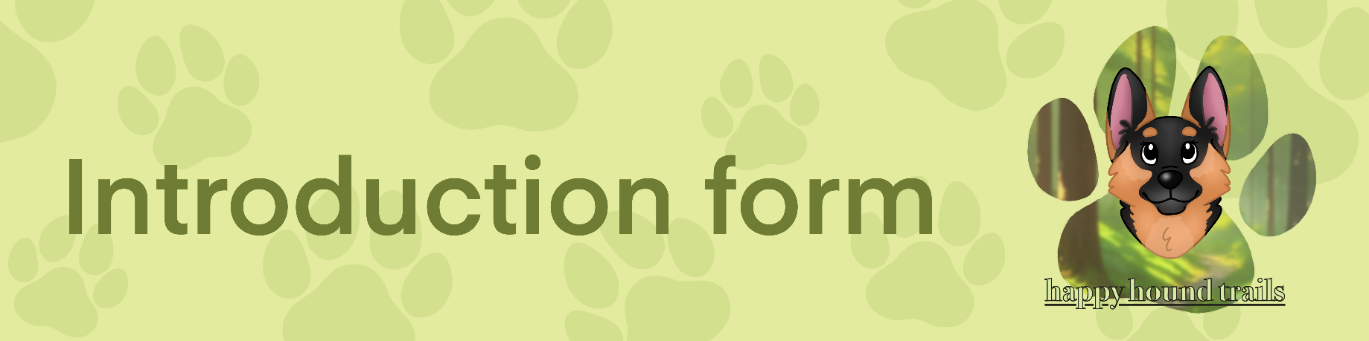

Contact and Client Profile
Please fill in all applicable fields to the best of your knowledge.

Client Contact Information

Clients full name: Click or tap here to enter text.
Address: Click or tap here to enter text.
Mobile phone: Click or tap here to enter text.
Email address: Click or tap here to enter text.

Emergency Contact Information

Emergency contact name: Click or tap here to enter text.
Mobile number: Click or tap here to enter text.
Relationship to owner: Click or tap here to enter text.

Vet Information

Vet name: Click or tap here to enter text.
Vet address: Click or tap here to enter text.
Phone number: Click or tap here to enter text. | Opening hours: Click or tap here to enter text.

Dogs Information

Dog name: Click or tap here to enter text. | Dog age: Click or tap here to enter text.
Breed: Click or tap here to enter text. | Sex: Male ☐ Female ☐
Neutered/spayed: Yes ☐ No ☐ | Fully vaccinated: Yes ☐ No ☐
Up to date with flea and worm treatment: Yes ☐ No ☐
Is your dog insured? Yes ☐ No ☐ | Insurer: Click or tap here to enter text.
Dog tag on collar: Yes ☐ No ☐ | Microchipped: Yes ☐ No ☐
Treats allowed: Yes ☐ No ☐
Allergies/intolerances: Yes ☐ No ☐ If yes, please provide details:
Click or tap here to enter text.

Medical conditions: Yes ☐ No ☐ If yes, please provide details:
Click or tap here to enter text.

Please provide details about your dog’s temperament:
Click or tap here to enter text.

Is your dog allowed off lead? Yes ☐ No ☐
Has your dog ever shown signs of aggression towards a person or another dog? (growls, lunges, snaps, bites, etc): Yes ☐ No ☐
Please explain below: If your dog shows serious aggression I will be unable to care for them due to safety concerns.
Click or tap here to enter text.

Any behavioural concerns (guarding things, noise phobias, etc):
Click or tap here to enter text.

Does your dog require a muzzle? Yes ☐ No ☐
Does your dog have a good recall? Yes ☐ No ☐

How does your dog respond to the following:
Cats: Click or tap here to enter text. | Dogs: Click or tap here to enter text.
Birds: Click or tap here to enter text. | Squirrels: Click or tap here to enter text.
People: Click or tap here to enter text. | Vehicles: Click or tap here to enter text.

House Information

Will you be providing a key? Yes ☐ No ☐
If not please provide details of how I will enter the home:
Click or tap here to enter text.

Will there be anyone in your home? Yes ☐ No ☐
Will the house alarm be on? Yes ☐ No ☐
Code: Click or tap here to enter text.
Restricted area of the house? Yes ☐ No ☐
Please specify:
Click or tap here to enter text.

Client Consent

Client name: Click or tap here to enter text. | Date: Click or tap to enter a date.
Client signature: Click or tap here to enter text.
Dog walker name: Milena French | Date: Click or tap to enter a date.
Dog walker signature: Click or tap here to enter text.

*Please print your name in the signature tab.

Additional information if applicable
Click or tap here to enter text.

